Questions or comments?

VA Palo Alto: Parisa Gholami- 650 493 5000 x62109 or Gholami.Parisa@Palo-Alto.va.gov
VA San Francisco: Stacey Young: 415 2214810 x4810 or stacey.young@med.va.gov
VA Durham: Melinda Orr: or Orr.Melinda@durham.va.gov

Training Manual for use of ATHENA

"The VA has adopted national practice guidelines for management of hypertension that closely follow the Joint National Committee on Hypertension VI (JNC-VI) guidelines for treatment. Your VA site is participating in the guideline implementation in the primary care clinics. Some forms of implementation include computer-based patient-specific treatment recommendations.”

For some of your clinic patients with hypertension, you will be receiving guideline-based recommendations about the management of hypertension. The recommendations will show in a pop-up window in the CPRS-GUI. The system that presents these recommendations is known as "ATHENA DSS". This manual shows you how to use ATHENA DSS.

Definition: ATHENA DSS is a computerized decision support system that interacts with VA databases providing patient specific recommendations on the management of hypertension through a pop up window on a computer screen.

Aims:
- Provide support to clinicians on the management of patients with a diagnosis of hypertension by displaying evidence-based individualized therapeutic recommendations at the point of care.
- Improve patient outcome by increasing compliance to evidence-based guidelines.

Patients excluded (Diagnoses are retrieved from the problem list, inpatient discharge diagnoses and encounter forms. If incomplete please update in CPRS):

- Children and adolescents (<18 yrs)
- Women of child bearing age (<50 yrs) or who are pregnant
- Creatinine ≥ 2.5
- Diagnosis of secondary hypertension or renovascular hypertension
- Diagnosis of spinal cord injury
- Diagnosis of idiopathic hypertophic subaortic stenosis
- Diagnosis of ascites
- BP defined as stage 3 hypertension (SBP≥180mmHg or DBP≥110 mmHg)
- Patient currently on ≥ 3 antihypertensive medications
- Narcolepsy
- Cyclosporine on active medication list
- Spironolactone on active medication list
- Minoxidine on active medication list

When does the window pop up?
The window will pop up when a patient with a diagnosis of hypertension on their problem have a scheduled visit to a primary care clinic. The pop up will usually be available one day before to one day after the scheduled appointment. You can not request a pop up.

When you click outside window pop up?

If you click outside the pop up window it will minimize and a “coffee mug” icon will appear on the taskbar (at the bottom of the screen). To see the pop up window click on the “coffee mug” icon.

How do you close the window pop up?
There are three ways to close the window:
- click on the  in the upper right hand corner or on the “Read”, “Not Read” or “Not Today” button at the bottom of the screen.
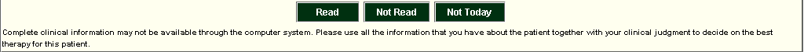

Contents of the pop up window (Hypertension Advisory)

Top third of “Hypertension Advisory” Pop up window
“Today’s Decision BP” field and “Date” field: allows clinician to insert BP and update the hypertension advisory
“Patient Name” field: displays patient name
“Patient Summary” (button): if you click this button, it will pop up “Patient Summary” (figure 2) window with information on vitals, adverse reactions/allergies, active antihypertensive drugs, lab values, related comorbidities and other comorbidities

“Most Recent BP in Database” field and “Date” field: displays most recent BP in VA database and corresponding date

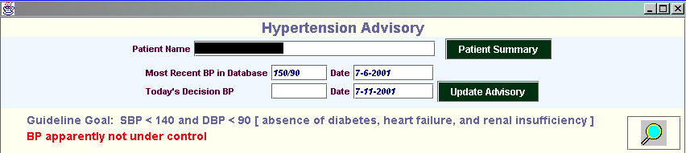
“Update Advisory” (button): will update recommendations based on BP inserted in “Today’s decision BP” and store the BP in the ATHENA database- not CPRS! If you wish to record it in the patient record in CPRS, use the vital signs field in VISTA.
“Guideline Goal” BP: Target BP for the individual patient based on presence/ absence of comorbitidies

Statement if BP is under control according to “Most recent BP in database“ or BP inserted in “Today’s decision BP” field: which ever has the most recent date
Magnifying glass icon: Can be dragged over titles and subtitles for definitions and over reasons for drug recommendations to view the evidence underlying a specific recommendation.

figure 2: “Patient Summary” window

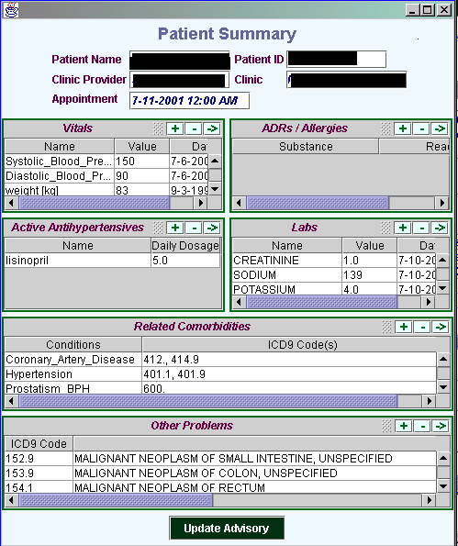
Comorbidities relevant to the choice of antihypertensive drugs. Diagnoses are retrieved from the problem list, inpatient discharge diagnoses and encounter forms. If incomplete please update in CPRS.
Scroll bars: click to scroll up or down

This window displays a summary of information relevant to the reasoning of therapeutic management of hypertension held in the VA database.

Middle third area of “Hypertension Advisory” Pop up window

7 Tabs (figure 3): (currently displayed tab in pink and hidden tabs in gray)
- Recommendations
- Comments
- Assumptions
- BP- Prescription Graphs
- Non-pharmacological management
- Medication adherence
- Glossary

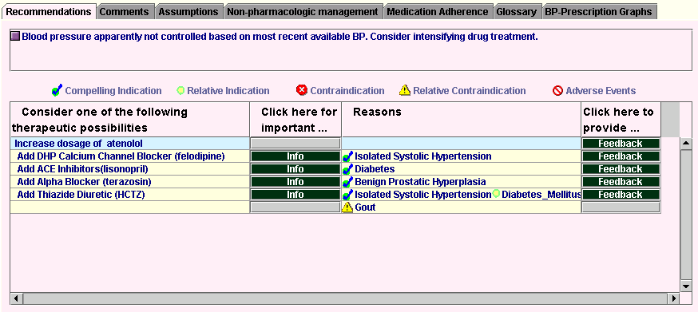

figure 3: Middle third of “Hypertension Advisory” Pop up window

Recommendations Tab
Icons used to highlight type of indication or contraindication in “Reasons” column based on data from the patient’s VA file.

Statement about BP control and recommended action

“Consider the following therapeutic possibilities”: therapeutic recommendations to increase dose, add, substitute or delete specific drugs
“Reasons”: reasoning underlying the specific drug recommendation with explicit icons

Click here for important…”: “Info” button is activated when there is important information for a specific drug recommendation.
“Click here to provide…”: feedback button will provide preset feedback to select from, free text feedback can be provided in the box at the bottom of the window.

Comments Tab
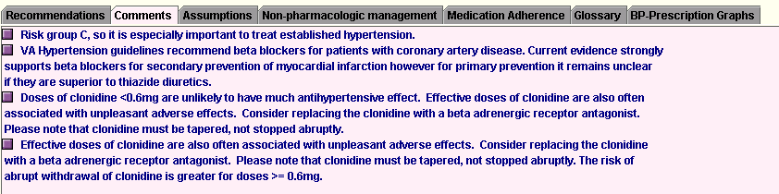
- Statements with information specific to this patient but not necessarily linked to a drug recommendation.

Assumptions Tab
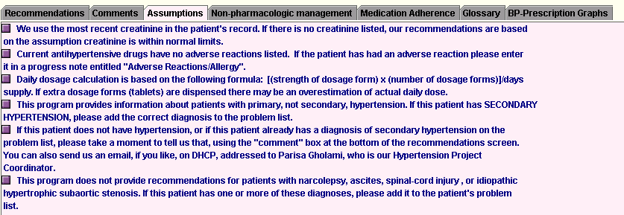
- Assumptions made by the ATHENA DSS. If data is missing from database ATHENA will assume no diagnosis of BPH, normal value for creatinine and no adverse events to active prescription and recommended drugs.

BP-Prescription Graphs Tab
- Historical graphical display of BP and prescription data. Data from FY1997 to present. Drug doses are displayed in boxes.
- Gaps in the lines of the prescription data may reflect lack of medication adherence.
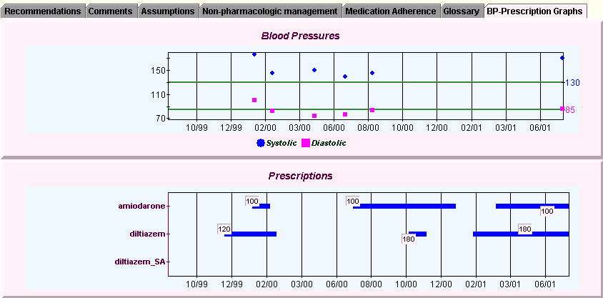

Non Pharmacological Management Tab

- General information related to lifestyle issues that may have an impact on hypertension such as diet, smoking cessation, exercise and alcohol consumption that may have an impact on hypertension.

Medication Adherence Tab
- General suggestions of ways to improve patient adherence to therapeutic regime.

Glossary Tab
- Definitions for terms used in pop up window

Bottom third of “Hypertension Advisory” Pop up window
Yellow area
Comments box field: type in your comments for the guideline team. They are welcome!

Not read button: press this button to close the window if you have not reviewed the content.

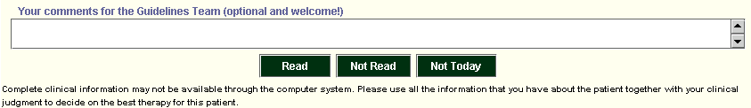
Read button: press this button to close the window after you have reviewed the content.

Disclaimer
“Not today” button: press this button to close the window if the patient has other clinical priorities than the management of hypertension.

Special Features to highlight

- Ability to update recommendations with different BP’s: insert BP in “Today’s Decision BP” field and press “Update Advisory” button. This BP will be kept in ATHENA’s database but not in CPRS.
- Update patient summary: data can be added or deleted from Patient Summary. However this data will be stored in ATHENA’s database only. It will not affect the VA database. If the clinician wishes to update patient data he/she should do so through CPRS.
- Magnifying glass: can be dragged over a field to display more information relative to that field. For example if dragged over a drug recommendation it would retrieve the evidence that underlies that recommendation.
- If patient does not have a diagnosis of hypertension, has a diagnosis of secondary hypertension, has a limited life expectancy (<=6 months) the clinician can request to exclude a specific patient. An email message should be sent to the local project coordinator (You can open DHCP to send email without closing your CPRS-GUI window):
  - VA Palo Alto: Parisa Gholami- Gholami.Parisa@Palo-Alto.va.gov
  - VA San Francisco: Stacey Young: stacey.young@med.va.gov
  - VA Durham: Melinda Orr: Orr.Melinda@durham.va.gov

